**SPRINT 3**

|  |  |
| --- | --- |
| **Date** | 19 november 2022 |
| **Project name** | Smart solutions for Railways |
| **Project id** | PNT2022TMID36774 |

**Team members:**

Sneha:210219106035

Banupriya:210219106007

Oviya:210219106027

Sakthi:210219106031

Developer web application:node red program

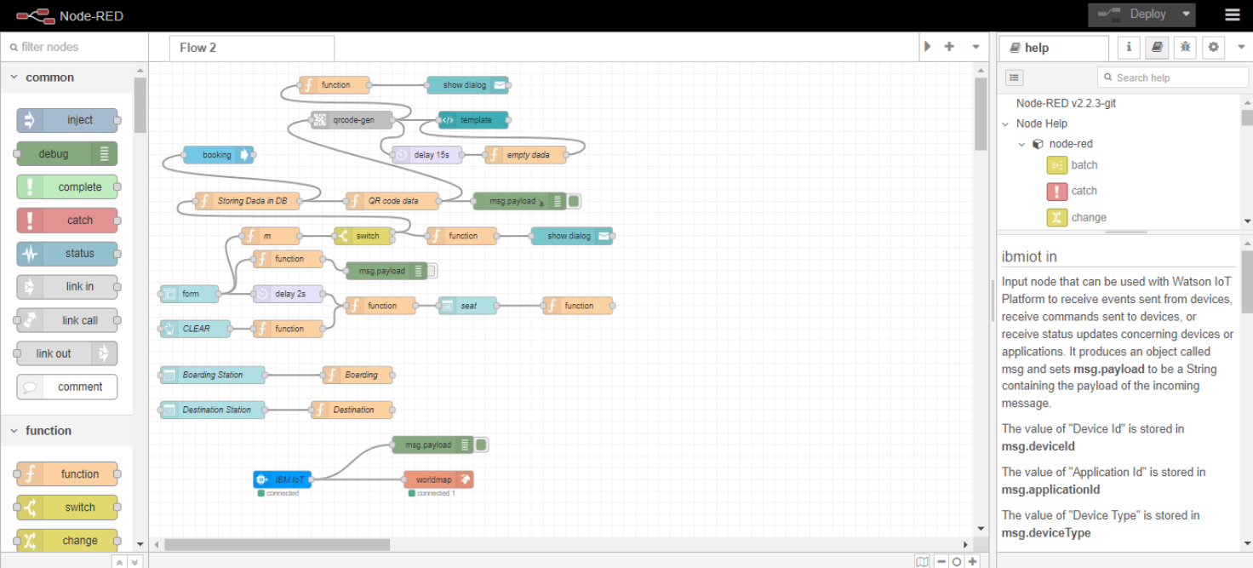

**Qr code generation:**

Import cv2

import numpy as np

import time

import pyzbar . pyzbar as puzbar

from ibmcloudant . cloudant_v1 import cloudantv1

from ibmcloudant import couchDbsessionAuthenticator

from ibm_cloud_sdk_core.Authenticators import BasicAuhtenticator

authenticator=BasicAuthenticator('apikey-v2-

16u3crmdpkghhxefdikvpssoh5fwezrmuup5fv5g3ubz','b0ab119f45d3e6255eabb978')

service =cloudantv1(authenticator=authenticator)

service.set_service_url('https://apikey-v2-

16u3crmdpkghhxefdikvpssoh5fwezrmuup5fv5g3ubz:b0ab119f45d3e6255eabb978')

cap = cv2.videoCapture(0)

font = cv2.FONT_HERSHEY_PLAIN

while True:

_, frame = cap.read(0)

decodeObjects = pyzbar.decode(frame)

for obj in decodeObjects:

#print("Data",obj.data)

a=obj.data.decode('UTF-8')

cv2.putText(frame,"Ticket",(50, 50),font, 2,

(255,0, 0), 3)

#print(a)

try:

responce = service.get_document (

db='booking',

doc_id = a

).get_result()

print(response)

time.sleep(5)

except Exception as e:

print ("Not valid Ticket")

time.sleep(5)

cap.imshow("Frame", frame)

if cv2.waitKey(1) & 0XFF == ord('q'):

break

cap.release()

cv2.destroyAllWindows()

client.disconnect()

**Ticket booking program:**

1. import wiotp.sdk.device
2. import time
3. import random
4. myConfig = {
5. "identity": {
6. "orgId":"i63nvt",
7. "devicetypeId":"GPS1",
8. "deviceId":"i2345"
9. },
10. "auth":{
11. "token":"abcdefghij"
12. }
13. }

14.

1. def myCommandCallback(cmd):
2. print("Message received from IBM IOT Platform: %s" % cmd.data['command'])
3. m=cmd.data['command']

18.

19. 'client = wiotp.sdk.device.DeviceClient(config=myConfig, logHandlers=None)' 20. 'client.connect()'

21.

1. def pub (data):
2. 'client.publishEvent(eventId="status", msgFormat="json",data=mydata, qos=0, onPublish=None)'
3. print("published data successfully: %s", mydata)

25.

26. while True:

27.

1. mydata={'name':'Train1','lat':17.6387448,'lon': 78.4754336}
2. pub(mydata)
3. time.sleep(3)
4. #mydata={'name':'Train2','lat':17.6387448,'lon': 78.4754336}
5. #pub(mydata)
6. #time.sleep(3)
7. mydata={'name':'Train1','lat':17.6341908,'lon': 78.4744722}
8. pub(mydata)
9. time.sleep(3)
10. mydata={'name':'Train1','lat':17.6340889,'lon': 78.4745052}
11. pub(mydata)
12. time.sleep(3)
13. mydata={'name':'Train1','lat':17.6248626,'lon': 78.4720259}
14. pub(mydata)
15. time.sleep(3)
16. mydata={'name':'Train1','lat':17.6188577,'lon': 78.4698726}
17. pub(mydata)
18. time.sleep(3)
19. mydata={'name':'Train1','lat':17.6132382,'lon': 78.4707318}
20. pub(mydata)
21. time.sleep(3)
22. client.commandCallback=mycommanCallbak
23. client.disconnect()

**Output:**

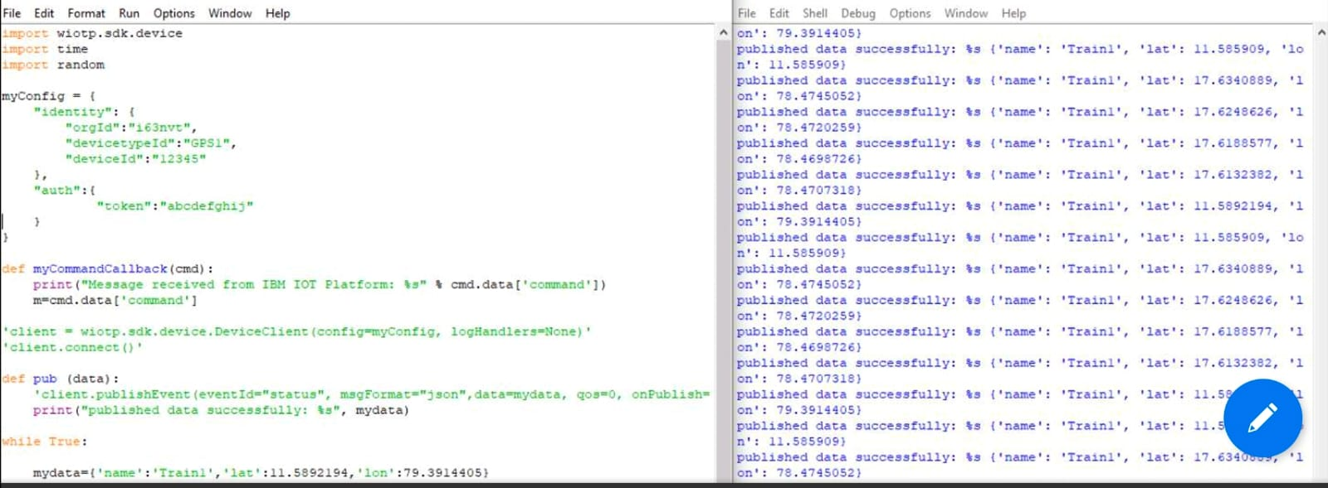

**MIT INVERTER:**

**App design model:**

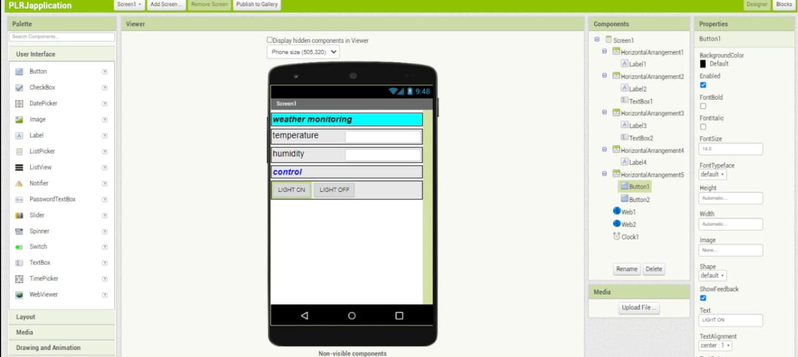

**Node red flow:**

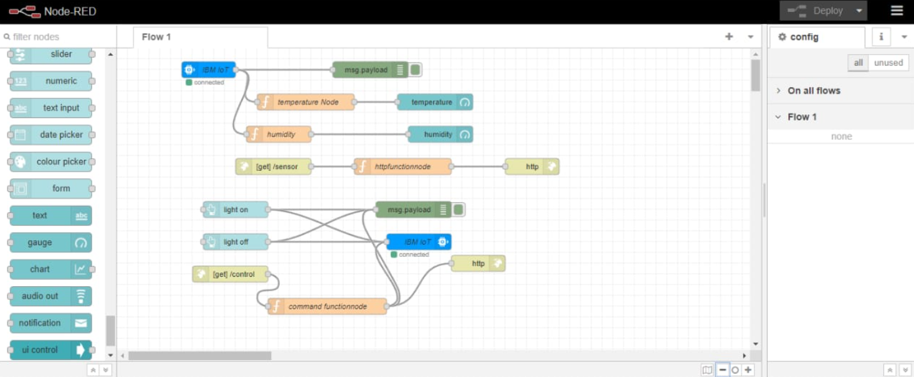

**Create mit app inverter:**

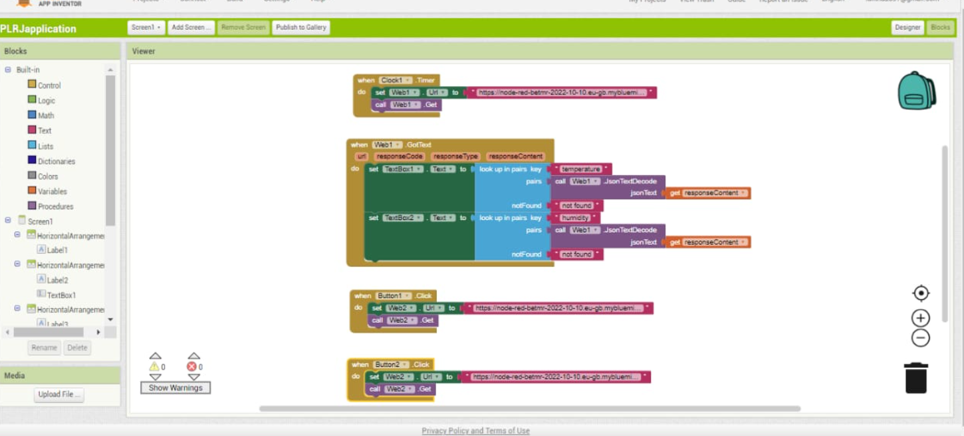

**Connecting mit app inverter:**

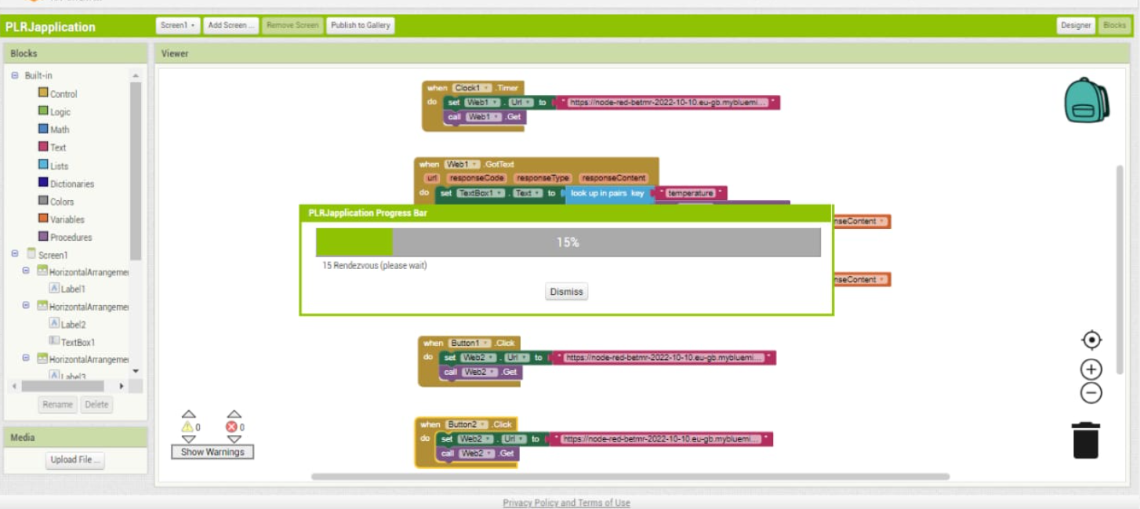

**Connect bar code:**

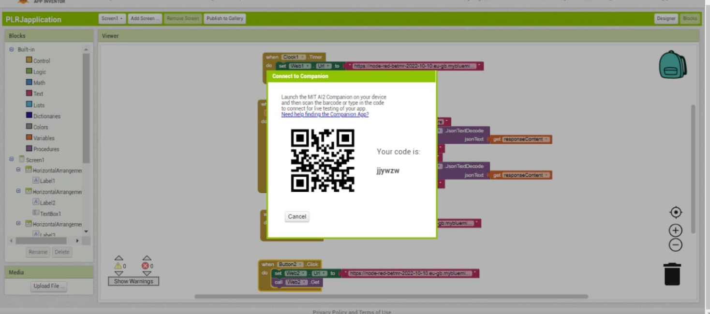

**Software screen mobile phone:**

